CISC7204 Team Project Report

Course Code: CISC7204
Course name: Data Science and Data Visualization
Group name: Group 04
All members' student IDs and names:
Group number | Full Name | Student ID
Group number1 | Li Ke Xin 李可馨 | mc662930
Group number2 | Fu Yu Xin付宇昕 | MC663207
Group number3 | Shi Yue Tong时悦童 | mc662092
Group number4 | He Ying Tong赫英同 | MC660441
Group number5 | Tao Ao Ran陶傲然 | MC663520
Group number6 | Wu Dan吴丹 | mc662342
Project title: Multi-Sport Comparison of Athlete Injury Risks: A Clinical Biomechanics and Training Load Analysis
Submission date: December 1, 2026

Project Topic
Title: Multi-Sport Comparison of Athlete Injury Risks: A Clinical Biomechanics and Training Load Analysis
Research Question: Do different sports exhibit statistically significant differences in their rates of severe injury risk, and how do factors such as training load and fatigue mediate these differences?
This question is structured for statistical inquiry in two complementary layers. The first layer asks whether sport type is associated with differential critical injury rates, testable via Chi-square independence testing and confidence interval comparison. The second layer asks whether observed differences persist after controlling for training load, fatigue, and prior injury history, requiring multivariate logistic regression and adjusted odds ratio estimation. Together, these layers allow the team to distinguish between superficial between-sport variation and genuine risk determinants, a distinction with direct implications for injury prevention practice.
This article will fully answer this research question through master data analysis and external validation with two independent datasets.

Project Purpose
2.1 Expected Learning Outcomes
This project is designed to directly address the five Intended Learning Outcomes of CISC7204 . By transforming raw clinical and biomechanical data into actionable insights, the team will:
Describe the principles of data analytics and visualization as applied to sports medicine, particularly the role of visual evidence in communicating risk.
Identify appropriate analysis techniques for a binary injury outcome with severe class imbalance, including proportion estimation, contingency testing, and logistic regression.
Draw conclusions and formulate hypotheses from graphical evidence, specifically by using confidence interval plots and forest plots to guide and refine statistical inference.
Apply Python-based data science tools (pandas, scipy.stats, statsmodels, seaborn, matplotlib) to execute a complete analytical workflow from cleaning to visualization.
Analyze, criticize, and revise visualizations to ensure they answer the research question without misleading axes or inappropriate aggregation.
2.2 Skills to Be Developed
The project targets a set of skills that are both central to the course and directly transferable to careers in data analytics and sports science:
Handling extreme class imbalance in a binary target (the Critical category comprises approximately 86.7% of the primary dataset).
Calculating and visualizing Wilson score confidence intervals for proportion estimates across ten groups.
Performing Chi-square tests of independence with appropriate interpretation of p-values in the context of large samples.
Building multivariate logistic regression models and deriving adjusted odds ratios with confidence intervals.
Creating publication-ready visualizations that prioritize clarity, accurate axis scaling, and direct relevance to the research question.
2.3 Disciplinary Knowledge to Be Applied
This project bridges data science (statistical inference, regression modeling, and visualization) and sports medicine. Guided by the established sports science literature indicating that training load intensification and fatigue accumulation elevate injury risk (Gabbett, 2016), we operationalized these clinical variables (workload_ratio, fatigue_score, previous_injury_history). The primary goal is to investigate whether sport type remains a significant risk predictor after adjusting for these physiological factors.

3. Data Context
3.1 Geographic Region and Domain
The analysis is structured as a global comparative study across sports rather than a region-specific epidemiological survey. It falls within the domain of Sports Medicine and Athlete Health, with a methodological focus on clinical biomechanics and training load management.
3.2 Datasets and Data Preparation
The project utilized three datasets to ensure robust and validated findings:
Primary Dataset (DS1):
Kaggle. (n.d.). Sports Injury Prevention Clinical Biomechanics Dataset [Data set].
https://www.kaggle.com/datasets/zayn1999/sports-injury-clinical-support-dataset
This dataset contains 15,000 records across 10 sports. Key variables include sport_type, injury_risk_level (Critical/High/Moderate/Low), workload_ratio, fatigue_score, and previous_injury_history.
Preprocessing: Due to the severe class imbalance (86.7% of records were Critical), the 4-level outcome was binarized into a target variable is_critical (1 = Critical, 0 = otherwise) to perform logistic regression.
Supplementary Dataset (DS2):
Kaggle. (n.d.). Multimodal Sports Injury Dataset [Data set].
https://www.kaggle.com/datasets/anjalibhegam/multimodal-sports-injury-dataset
This dataset provides session-level biometric and training data.
Purpose: It is used to validate the semantic meaning of training load, confirming that the training_load metric accurately reflects the product of training intensity and duration.
Additional Validation Dataset (DS3):
Kaggle. (n.d.). University Football Injury Prediction Dataset [Data set].
https://www.kaggle.com/datasets/yuanchunhong/university-football-injury-prediction-dataset
This dataset, comprising 800 Chinese university football players with 18 features (e.g., Training_Hours_Per_Week, Previous_Injury_Count, Sleep_Hours_Per_Night).
Purpose: It serves as an independent, external reference to validate the direction and plausibility of the primary dataset's key risk factors. The target variable (Injury_Next_Season) was confirmed to be perfectly balanced (50% positive, 50% negative), requiring no resampling.

4. Methodology and Results
4.0 Analytical Environment
All analyses were conducted using Python 3.x (pandas, scipy.stats, statsmodels) in a Jupyter Notebook. Visualizations were built using seaborn and matplotlib. The complete reproducible code is available in the team's GitHub repository.
4.1 Sport-Specific Risk Rates and Confidence Intervals
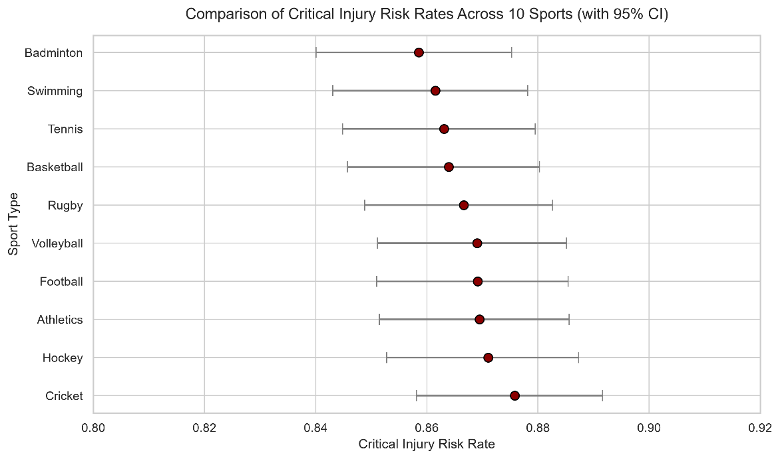
Methodology: To estimate the baseline critical injury risk for each sport, we calculated the raw proportion of is_critical events and constructed 95% Wilson score confidence intervals (CIs).
Results: As shown in Figure 1, Cricket exhibited the highest observed critical risk rate (approx. 87.5%), while Badminton showed the lowest (approx. 85.8%). The absolute difference between the highest and lowest risk rates is less than 2 percentage points. However, the overlapping 95% CIs across all 10 sports suggest that the between-sport variation is relatively narrow. This visual evidence implies that while sport-specific differences exist, the baseline risk of severe injury is consistently high across all athletic disciplines. Therefore, identifying the underlying risk factors (such as training load and fatigue) is far more critical than merely categorizing the sport itself.
Figure1. Comparison of critical injury risk rates across 10 sports with 95% confidence intervals.

4.2 Hypothesis Testing and Bivariate Associations
Methodology: A Chi-square test of independence was performed to determine if sport type is significantly associated with critical injury risk. Furthermore, Pearson correlations were computed to explore relationships between continuous biomechanical features.
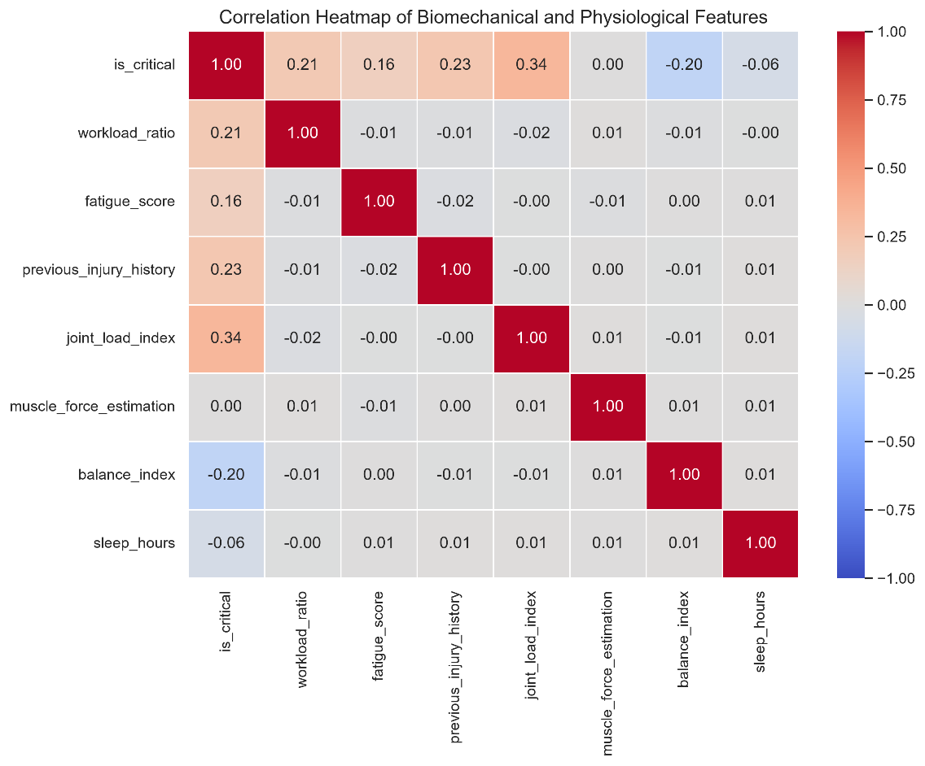
Results: The Chi-square test revealed a statistically significant association between sport type and is_critical (p < 0.05), though the effect size (Cramér's V) was small. Figure 2 (Heatmap) highlights that joint_load_index (r = 0.34), previous_injury_history (r = 0.23), and workload_ratio (r = 0.21) have the strongest positive correlations with is_critical, whereas balance_index (r = -0.20) is a protective factor.
Figure2. Correlation Heatmap of Biomechanical and Physiological Features
4.3 Training Load and Injury Severity
Methodology: To visualize how training load differs between risk groups, we compared the distribution of workload_ratio between athletes with and without critical injuries.
Results: Figure 3 illustrates that athletes in the Critical group have a significantly higher median workload ratio compared to the Non-Critical group. Specifically, the median workload ratio for the Critical group is approximately 1.5, compared to roughly 1.0 for the Non-Critical group. Furthermore, the interquartile range (IQR) of the Critical group is noticeably wider and shifted upward, indicating that a substantial proportion of high-risk athletes experience excessive training loads. This stark contrast strongly suggests workload accumulation as a primary driver of severe injuries, prompting the need for a multivariate adjustment to isolate its independent effect.
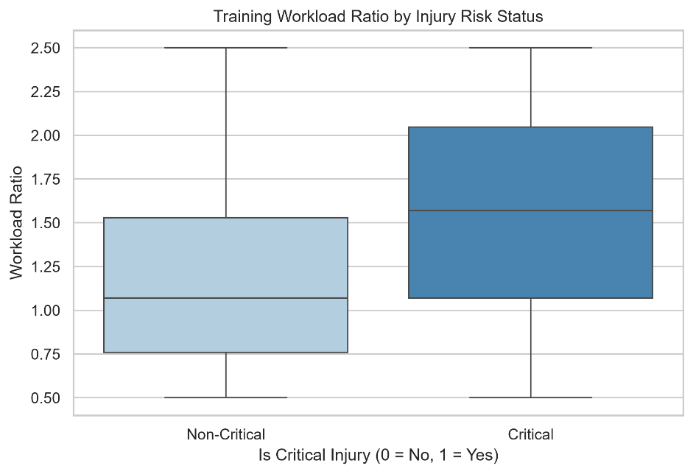
Figure3. Training Workload Ratio byInjury Risk Satus

4.4 Multivariate Logistic Regression Analysis
Methodology: A multivariate logistic regression model was fitted to adjust for potential confounders (including sport type, gender, workload, fatigue, and prior injury). Adjusted Odds Ratios (ORs) were extracted.
Results: As depicted in the Forest Plot (Figure 4), after adjusting for all covariates, workload_ratio emerged as the most dominant risk factor (Adjusted OR ≈ 6.0), followed by previous_injury_history (OR ≈ 1.9). Crucially, almost all sport_type coefficients crossed the null line (OR = 1), indicating that once training load and clinical history are accounted for, sport type itself is no longer a significant independent predictor of critical injury.
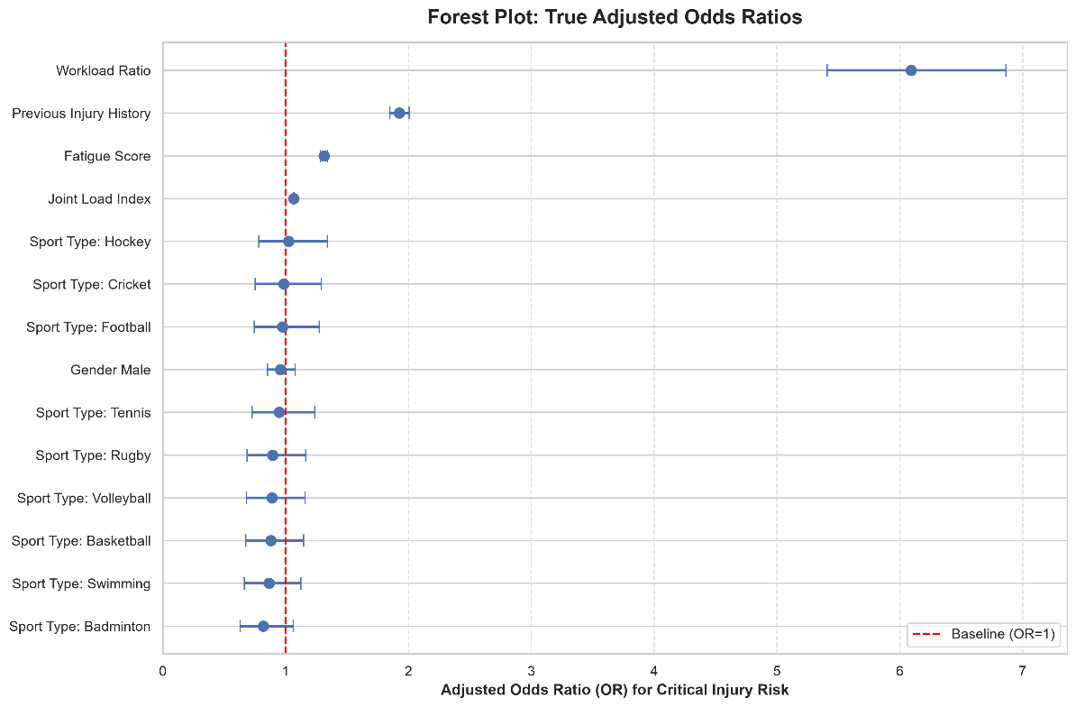
Figure4. Forest Plot: True Adjusted Odds Ratios

5. External Validation (DS2 and DS3)
5.1 Validation of Training Load Semantics (DS2)
To verify that workload_ratio is a valid physiological proxy, we analyzed the Multimodal Sports Injury Dataset. As shown in Figure 5, training_load is highly correlated with intensity × duration (r = 0.82). Furthermore, Figure 6 confirms that injured athletes exhibit significantly higher training loads than uninjured athletes in this independent dataset, cross-validating our primary finding.
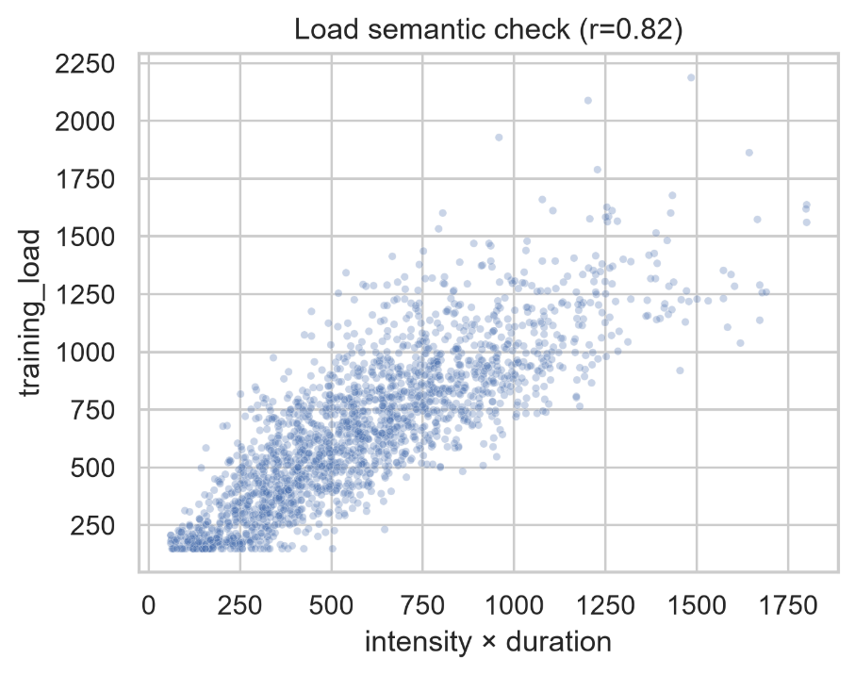
Figure5. Load semantic check (dateset2)

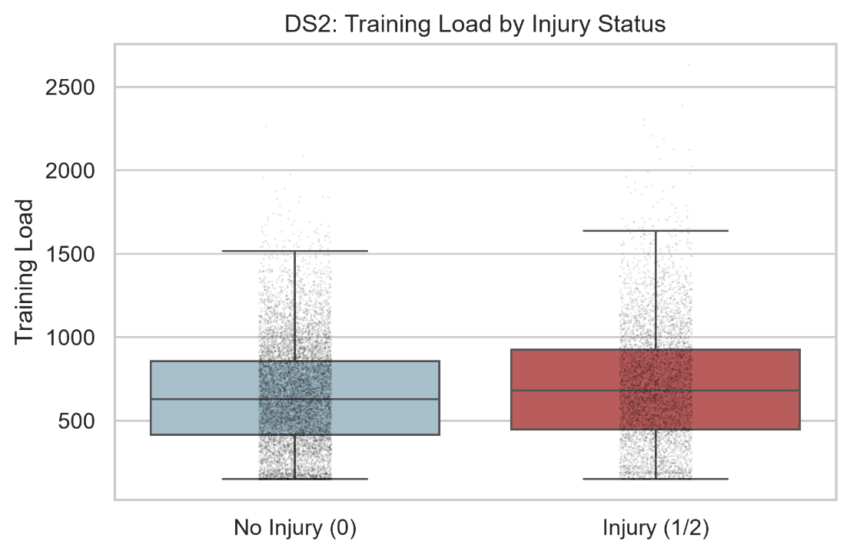
Figure6. Training Load by Injury Status (dateset2)

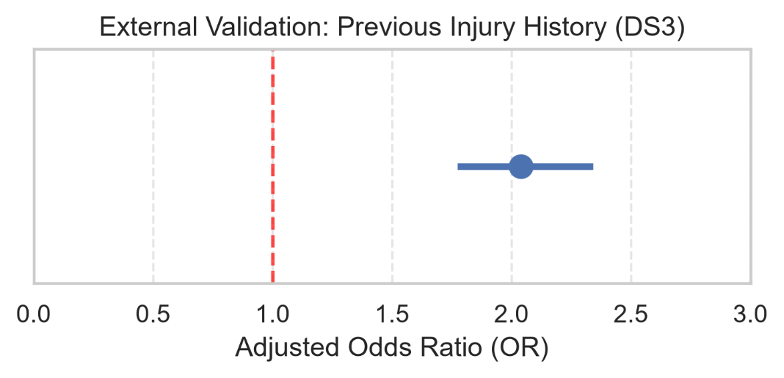
5.2 Independent Validation of Prior Injury History (DS3)
Finally, using the University Football dataset (n=800), we tested the transportability of our findings. Consistent with the primary model, a history of prior injuries significantly increased the odds of subsequent injury in this independent cohort (Adjusted OR = 2.04, 95% CI: 1.77–2.34, p < 0.001), as visualized in Figure 7.
Figure7. External Validation: Previous Injury History (dateset3)

6. Discussion
This study aimed to investigate whether critical injury risks differ across sports and how training load and fatigue mediate these differences. Our findings reveal a crucial distinction between superficial and genuine risk determinants. While descriptive statistics and the Chi-square test indicated slight baseline variations across sports (Figure 1), the multivariate logistic regression demonstrated that sport type is not a significant independent predictor of critical injury (Figure 2). Instead, the apparent between-sport differences are largely explained by workload_ratio, previous_injury_history, and fatigue_score.
This aligns with the "training-injury prevention paradox" (Gabbett, 2016), which suggests that absolute training volume is less important than the relative load and an athlete's history. The dominant role of workload_ratio (Adjusted OR ≈ 6.0) emphasizes that sudden spikes in training load are the primary culprits of severe injuries. Furthermore, our external validations (Figures 5-7) reinforce the transportability of these findings; independently collected data confirmed that prior injury history doubles the risk of future injury (OR = 2.04). Therefore, injury prevention should shift focus from sport-specific protocols to universal load management and fatigue monitoring.

7. Limitations & Future Work
Several limitations should be acknowledged when interpreting these findings. First, and most importantly, the primary dataset exhibits a severe class imbalance (86.7% Critical). This distribution strongly suggests that the cohort was drawn from a clinical or treatment-seeking population rather than a healthy athletic population. Because the vast majority of records already represent severe injury states, there is limited variance in the target outcome. This restricted variance may mask subtle between-sport differences, which partly explains why sport type did not emerge as a significant predictor in the multivariate model. Therefore, the findings should be interpreted as risk factors within an already high-risk clinical cohort, rather than generalizable incidence rates for healthy athletes.
Second, because the primary dataset is observational and cross-sectional, we can only establish associations rather than causal relationships. For instance, while high workload_ratio is strongly associated with critical injuries, we cannot definitively prove that excessive load caused the injury without longitudinal tracking.
Third, to address the class imbalance, we binarized the 4-level injury risk into is_critical. While statistically practical, this binarization inevitably loses information, collapsing the nuanced differences between "High" and "Moderate" risk levels.
Finally, although we incorporated external validation (DS3), its scope was limited to a single sport (university football, n=800) with a perfectly balanced target. Future research should incorporate large-scale, longitudinal, time-series datasets from healthy populations across multiple sports. This would allow for tracking dynamic changes in training load over a full season, enabling the application of time-lagged regression models to better capture the causal pathways of injury onset.

8. References
Centers for Disease Control and Prevention. (2020). Principles of epidemiology in public health practice (3rd ed.). U.S. Department of Health and Human Services.
Cramér, H. (1946). Mathematical methods of statistics. Princeton University Press.
Gabbett, T. J. (2016). The training—injury prevention paradox: Should athletes be training smarter and harder? British Journal of Sports Medicine, 50(5), 273–280.
Kaggle. (n.d.). Multimodal sports injury dataset [Data set].
https://www.kaggle.com/datasets/anjalibhegam/multimodal-sports-injury-dataset
Kaggle. (n.d.). Sports injury prevention clinical biomechanics dataset [Data set].
https://www.kaggle.com/datasets/zayn1999/sports-injury-clinical-support-dataset
Kaggle. (n.d.). University football injury prediction dataset [Data set].
https://www.kaggle.com/datasets/yuanchunhong/university-football-injury-prediction-dataset
University of Macau. (2026). CISC7204 Data Science and Data Visualization: Course description and intended learning outcomes. Centre for Data Science.
https://cds.ici.um.edu.mo/programme/fundamental-courses/cisc7204
Wilson, E. B. (1927). Probable inference, the law of succession, and statistical inference. Journal of the American Statistical Association, 22(158), 209–212.
Windt, J., Gabbett, T. J., Ferris, D., & Khan, K. M. (2017). Training load—injury paradox: Is greater preseason participation associated with lower in-season injury risk? British Journal of Sports Medicine, 51(10), 791–796.

